Helen Shembo  
Brewer Alexandra  
WRI 0105  
27 May 2024

Of all these great places in the world, Central Park is one of the places that I am so familiar with and have been to numerous occasions. He said that it symbolized a restful haven amidst the chaotic metropolis and provided a rich source of physical stimuli. Division based on the separation of nature and city life gives rather astonishing number of opportunities for the detailed and rather clear descriptions of the scenes.

3. Well done! Now it is time to spell out your goals and be specific: What specific change would you like to see happen?

I want my audience to be left with feeling that there is order in this world and that nature and man-made structures coexist in a peaceful and aesthetically appealing manner.

4. So, what will be your approach when it comes to organization of your work?

In the work, I will indicate that the first part of the park presents elements from the right part of the picture up to the left one. This spatial arrangement will enable the achievement of the logic flow of information as per the planned spatial arrangement.

5. Fill in the chart below with as much information as possible.

|  |  |  |  |  |
| --- | --- | --- | --- | --- |
| SIGHT | SOUND | TASTE | TOUCH | SMELL |
| People standing and talking on the right. | People laugh and chat. | Flavored drinks or snacks (eg ice cream, lemonade) brought to the park to enjoy. | Soft, cool grass underfoot. | It smells like freshly cut grass. |
| People sit by the fire. | The leaves are rustling in the wind. |  | The warmth of the sun on the skin. | The smell of flowers and trees. |
| The wide green grass stretches to the sky. | The sounds around the park, including the distant city traffic. |  | The breeze blows against your face. | The smell of food from a nearby vendor. |
| People lying on blankets in the sun. | He gets occasional shouts from people playing the game. |  | The rough construction of a picnic blanket. | A hint of city air mixed with the scent of nature. |
| A dense tree line creates a natural barrier. | The birds are chirping in the trees. |  | Flat garden bench. |  |

**Selected location:**

Central Park, New York City.

**Picture:**

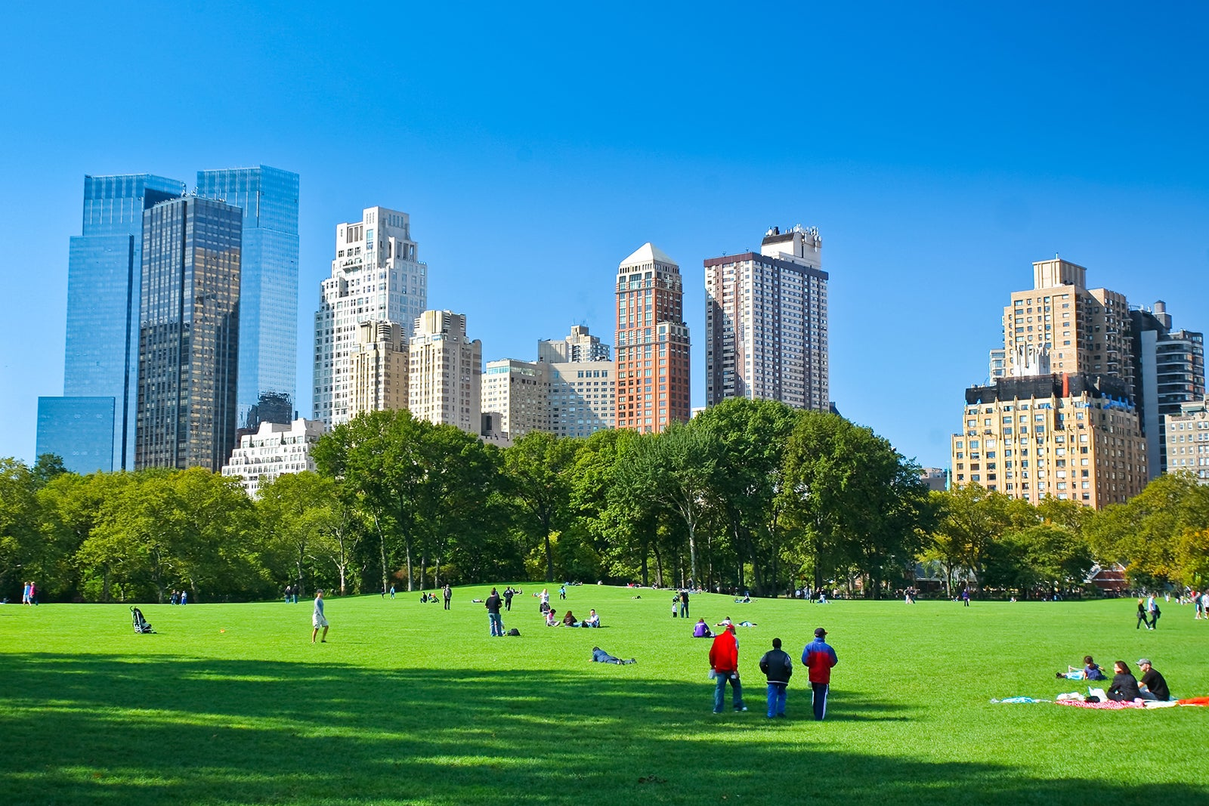

**Image Description:**

There are people having fun in Central Park on a sunny day, and the sky is clear blue. The grounds are green, and the buildings are tall.

**Plans**

**Overview:**

At its best, Central Park is an urban green zone with an active pace of life immersed in the chaos of NY.

Details:

right:

An assembled group of individuals wearing no formal or traditional garbs are standing and having a conversation.

Some people sit by the fire and start their own business Some people bare their behinds to the public Some people paint their nails and put on lipstick and wear a short skirt and go robbing Som people sit by the fire and start their own business.

before:

Green and expansive grass extends only as far as the eye can see up into the sky.

Some drive about in cars, while others sit on blankets to enjoy the sun.

Then:

If there are a big tree around it then the leaves serve as partitions.

This is a spectacular view due to the high rise buildings around New York especially atop which are green vegetations.

Left:

Recreation such as kids playing with a frisbee with their friends or groups of friends having taken a meal on a picnic.

Comfort makes a joyful home for a poor man.

The results:

Looking at the landscape of accessible areas for rest, Central Park can be recommended as a great opportunity to escape from the everyday civilization problems for city people with remains of nature mixed with city atmosphere.

**First Draft:**

NYC is an urban city and Central Park adds the feel of a green lungs that is surrounded by concrete jungles. To the right of it, subjects in backless, free-flowing clothing converse and gesture dramatically; several individuals are seated next to the fire, busy with their tasks. In front of it, an enormous grassy area aims at touching the sky and several people can be seen lying down on the grass, completely relaxed on the blankets, savoring the warmth of the sun. Behind them was a line of trees to make it natural for the occupants of the house not to see anyone passing by lest the tall trees of napping leaves did not hide enough. In the background there are towering skyscrapers of New York City – they look proud and magnificent, but at the same time they seem to be rather out of place here and are in contrast to the green surroundings. On one side there is a group of friends this time few in number and they are playing Frisbee or having a picnic the sound of their laughs blend with the rest of the park. The average person cooks, eats, gains energy, rests and becomes comfortable, gets fresh air. This place is exceptional when it comes to the normal people who live in the city, who can fully understand and identify with the bond between nature and concrete jungle, between lush greens and concrete jutes.

**Polish Draft:**

A Day in Central Park:

They tend to be located in the large central parks in the midst of the intense concrete jungle that characterizes New York City. On the right is a group of people wearing outfits with exposed skin and legs and continuously talking to each other; some people are seated near the fire engrossed in their activities. Somewhat in front of you, there is a vast and bright green grass that reaches high up to the heavens, where several individuals are resting on one or the other available blankets, enjoying the warm sunlight. Behind him the trees stood in a grove creating more privacy for the couple and swaying gently in the wind. The buildings of New York are portrayed in the backdrop with a majestic look and are a stark opposite to an area full of trees and grass. On the left side, several friends are in the midst of tossing a frisbee or eating a sandwich and chatting, which are some noises around the park. The average man or woman, unwind, take comfort with fresh air. Central Park provides the city dwellers with an ideal opportunity to Jogging to another level the extent to which people can immerse themselves with natural surroundings and the principally urban-within-a-park environment. Lavender and grass clippings are the two fragrances that can be easily distinguished; the air has a sense of feel and freshness as well as the far off hum of traffic.